COUNCIL ROCK NORTHAMPTON BASEBALL



2025 Safety Awareness Program Manual

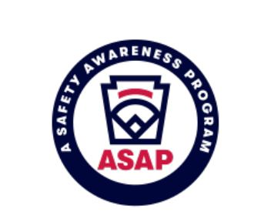

BE SAFE… PLAY HARD… HAVE FUN!

Season 2025

Dear Managers, Coaches, Volunteers and Umpires:

Welcome to another fun and exciting season of Council Rock Northampton Baseball (CRNHBB)! As a chartered Little League Organization, CRNHBB is required to develop, implement, and submit A Safety Awareness Program (ASAP) to the Little League Data Center on an annual basis. This manual was developed to not only comply with the Little League ASAP requirements, but to help the children of CRNHBB have an enjoyable, memorable, and SAFE experience as a Northampton Baseball member. Introduced in 1994, ASAP has already increased Little League’s overall safety awareness nationwide which has prevented and reduced injuries by approximately 80% during Little League events, as well as reduced insurance costs for participating leagues. Those results alone demonstrate the “win-win” nature of the program and the positive impact it has had for Little League communities over the years. As part of ASAP, Little League organizations are encouraged to develop a local safety program that contain at a minimum (15) safety-related requirements, with the idea that this basic safety plan can be expanded and enhanced to meet the needs of the individual league. The (15) required elements of Little League’s ASAP include:

- Requirement 1: Safety Officer
- Requirement 2: Safety Manual Distribution
- Requirement 3: Emergency Plan
- Requirement 4: Volunteer Requirements
- Requirement 5: Fundamentals Training
- Requirement 6: First Aid training
- Requirement 7: Check Field Conditions
- Requirement 8: Facilities Survey
- Requirement 9: Concession Stand Safety
- Requirement 10: Equipment Check
- Requirement 11: Accident Reporting
- Requirement 12: First Aid Kits
- Requirement 13: Enforce Little League Rules
- Requirement 14: Player & Coach Data
- Requirement 15: Annual Survey

CRNHBB has not only met the (15) safety-related requirements of Little League’s ASAP but has also enhanced the safety awareness of the Northampton Baseball Community with the following additional elements of CRNHBB’s Safety Program.
- Developed a one-page information sheet with a diagram identifying the lay-out of the field complex and placed signage at each field location so that they are easily identifiable for players, coaches, families, spectators, volunteers, umpires, and other visitors to the CRNHBB complex. This diagram is included in this safety manual and is circulated to our community first responders (fire, police and EMTs) so that they are familiar with the complex layout, parking area, and access to each field location, in particular should their services be needed in a timely manner.
- Improvements were made to parking lots at the complex, including markings, painting and signage for motorists and pedestrians at the facility.
- (3) Automatic External Defibrillators (AEDs) are available and accessible in all fields during baseball season. The AEDs are located at the main and secondary snack stand areas as was as the Northampton Township Civic Center main building and will be placed in conspicuous locations during all games/practices at the complex for use during an emergency.
- In addition to the required First Aid Training, at least one adult member of each team at each level of play (in-house and travel) and league Board Members will be trained in Adult/Child CPR and the appropriate use of the AED.
- Concession Stand Safety information will be posted and communicated to all volunteers who assist with food handling or food preparation at CRNHBB’s Snack Stand locations.
- Emergency Contact information for local first responders (police, fire, and EMT) and Board Members responsible for elements of ASAP will be listed in this manual and posted at the concession stands.
- Umpires and Team Managers (head coach or assistant coach) will be required to walk-the-field and inspect all equipment (league and player owned) prior to any CRNHBB sanctioned practice/game. Only acceptable and approved sports equipment will be used during practices and games.
- Comprehensive background checks will be performed on all coaches/assistant coaches, volunteers, and board members, as part of PA State Law. Additional information about the information that is required for volunteers can be found here: https://www.crnorthampton.com/forms
- Placement of Warning/Safety Signs in the dugout areas of each field to communicate safety expectations and to minimize injuries to players, coaches, and spectators.
- CRNHBB’s Safety Director will use the ASAP Newsletter to communicate information to the CRNHBB Community. Additionally, the Safety Director will distribute other safety fliers throughout the season (via website, social media, and/or hard copies) with information about relevant safety topics such as heat stress awareness, lightning safety, concussion safety, traffic and parking/lot safety, equipment safety, mental and emotional wellbeing topics, and more.
- CRNHBB ASAP and Code of Conduct will be shared with league participants including all coaches, parents, and volunteers at the beginning of each season. A copy of this manual will be available in hard copy at the Main Shack and an electronic copy will be filed on CRNHBB’s website.

It is expected that all players, coaches, managers, parents, volunteers, and Board Members will act responsibly and in accordance with our safety standards and other CRNHBB guidelines. CRNHBB’s Board of Directors is committed to enforcing this Safety Manual and is proof that CRNHBB is dedicated to our cause of providing an enjoyable, memorable, and safe environment for all members of the Northampton Baseball Community.

Please read this manual carefully, as it will familiarize you with CRNHBB’s safety procedures and expectations. Use this manual as a reference throughout the season and should you have any questions, comments, or concerns about CRNHBB’s ASAP or other safety concerns, please feel free to contact the Safety Director or a current Board Member to assist you.

Lastly, but most importantly… Thank you, PARENTS for entrusting us with your children this season and thank you COACHES, ASSISTANT COACHES, TEAM PARENTS and other VOLUNTEERS – we cannot run this organization without the selfless giving of your time and commitment to our community’s children. Thank you again for all your support! PLAY BALL!!!

Regards,
Tom Cashman, President CRNHBB
Dan Hoelzle, Safety Officer, CRNHBB

Season 2025

Table of Contents

Section I: Mission Statement
Section II: Organizational Information
Section III: Location Map
Section IV: Emergency Contact Information
Section V: Northampton Baseball Code of Conduct
Section VI: General Safety Rules
Section VII: Coaches, Parents and Player Responsibilities
Section VIII: A Safety Awareness Program (ASAP)
Section IX: Supplemental Safety Information

Section I: CRNHBB MISSION STATEMENT

Council Rock Northampton Baseball (CRNHBB) is a 501(c)(3) organization constituted to firmly instill in children of our local community the values of good sportsmanship, honesty, loyalty, courage, and respect for authority, so that they may be well-adjusted, stronger, and happier children that will grow to be good, decent, healthy, and trustworthy citizens. CRNHBB provides an opportunity for our community’s children to learn and enjoy the game of baseball in a safe and friendly environment in which they can thrive.

For specific information regarding CRNHBB please visit:
Council Rock Northampton Baseball – www.crnorthampton.com
Section II: CRNHBB Organizational Information



Mailing Address: Council Rock Baseball Association Inc.
PO Box 61
Richboro, PA 18954

Street Address: Northampton Township Recreation Complex
345 Newtown-Richboro Road
Richboro, PA 18954

General Email: board@crnorthampton.com

Council Rock Northampton Baseball
2025 Board of Directors
2025- CR Northampton LL Board | Person | E-Mail
Executive Board | General Mailbox | board@crnorthampton.com
PRESIDENT | Tom Cashman | president@crnorthampton.com
VICE PRESIDENT | Aaron DiCaprio | orangecrush626@gmail.com
PLAYER AGENT (PRIMARY) | Dan Brown | playeragent@crnorthampton.com
CO-PLAYER AGENT | Steve Torpey | TorpeySteve2003@gmail.com
CO-PLAYER AGENT | Ken Meister | kmeist98@gmail.com
TREASURER | TJ Derrico | treasurer@crnorthampton.com
SECRETARY | Mike Murphy | secretary@crnorthampton.com
VP - MAJORS (AAA, AL, NL) | Tom Orrino | orrinot@gmail.com
VP - MINORS (QUICKBALL, BAMBINO, ROOKIE, SINGLE A) | Keith Landi | kmlandi@gmail.com
2025 - CR Northampton LL General Board Members | Person | E-Mail
DIRECTOR - FIELDS AND FACILITIES | Dan Brown | daniel.c.brown@phila.gov
DIRECTOR - TRAVEL | Dan Brown | daniel.c.brown@phila.gov
DIRECTOR - PROCUREMENT | Ken Meister | kmeist98@gmail.com
DIRECTOR - UMPIRES | Christine Yordy | cyordy826@aol.com
DIRECTOR - INSURANCE | Tom Orrino | orrinot@gmail.com
DIRECTOR - SPONSORS/MARKETING/FUNDRAISING/EVENTS | Giselle Fittizzi | fundraising@crnorthampton.com
DIRECTOR - IT AND WEBSITE (ACTING) | Tom Cashman | president@crnorthampton.com
DIRECTOR - SCHEDULING (ACTING) | Tom Cashman | president@crnorthampton.com
DIRECTOR - SNACK SHACK/CONCESSIONS | Julie Meister | bryermeister@gmail.com
SAFETY OFFICER | Dan Hoelzle | dhoelzle75@gmail.com
EQUIPMENT MANAGER | Mike Heise | mph75@comcast.net
EQUIPMENT MANAGER | Ken Wagher | kennethwagher@gmail.com
GENERAL BOARD MEMBER | TJ Cieri | tcieri326@gmail.com
GENERAL BOARD MEMBER | Paul Kovaleski | paul@pkinsures.com
GENERAL BOARD MEMBER | Chad Cunnius | cunniusfamily@gmail.com
GENERAL BOARD MEMBER | Pat Scanlon | patrickwscanlon@gmail.com
GENERAL BOARD MEMBER | Jeff Bibus | jmb9squibbs@msn.com
GENERAL BOARD MEMBER | Mike Wade | mikejwade15@gmail.com

Section III: CRNHBB Location Map
AED
AED
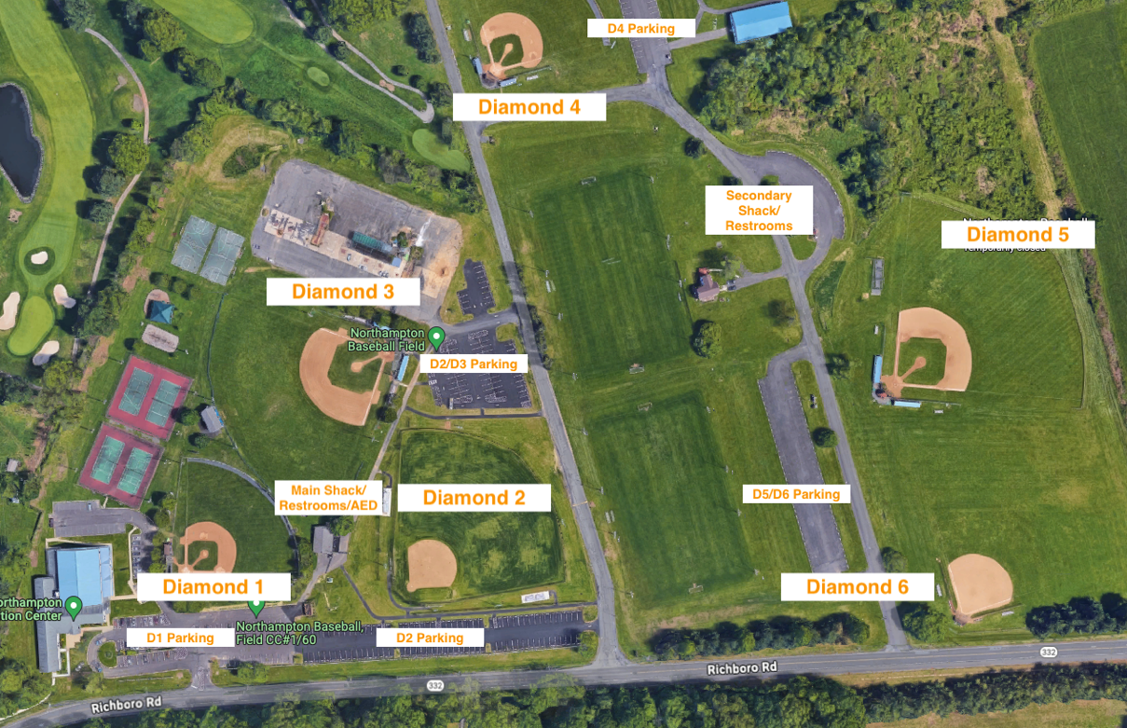

The Northampton Township Recreation Complex (NHT Rec Complex) is a 61.8-acre park that houses athletic facilities and the Recreation Center. This complex is home to the 2007 Pennsylvania Little League Champions and home to the Council Rock Northampton Baseball Association, Northampton Indians Football Association, Council Rock United Soccer Association and Northampton Township Homeowners' Softball League. These sports organizations work with the Township to maintain the fields which include 2 lighted little league field, a lighted baseball/football field, a lighted baseball/softball field, a 90' baseball field, a 60' field, 4 lighted soccer fields, a lighted soccer practice area and smaller soccer fields. These fields are generally assigned to the sports groups for facilitation of the sports leagues.
For a Full List of Recreation Center Programs and information - Click Here

Section IV: Emergency Contact Information

Police, Fire, & Ambulance Emergency – Dial 911

Location information can be found on every field’s 1st and 3rd base location.

St. Mary’s Medical Center – 215-710-2000
1201 Langhorne-Newtown Road
Langhorne, Pa 19047

National Poison Control Center - 800-222-1222
PECO - 1-800-841-4141 (to report a gas leak or other emergency to PECO, first leave the area and then make the call.)

Non-Emergency & Key Officials Phone Numbers
This page must be posted in a prominent location in the snack stand during each season.
Northampton Township Police Department 215–357-8700

Northampton Township Parks and Rec. Department 215-357-6800

Northampton Township Fire Department 215-357-8277

Emergency Medical Services (EMS) 215-357-0473

Tom Cashman, CRNHBB President 267-242-9405

The Main Shack will keep an airhorn for use of immediate communication to evacuate all fields, typically used in weather-related emergencies. An adult volunteer may sound one airhorn blast to signal an evacuation of all fields, dugouts, and other non-permanent structures at the facility. Solid buildings with plumbing and electrical grounds or hard-topped vehicles can be used as shelters in the event of an emergency evacuation.

Section V: CRNHBB Northampton Baseball Code of Conduct

All Participants (parents, coaches, and volunteers):

When attending a CRNHBB event (i.e., games, practices, etc.).
- I will encourage sportsmanship by demonstrating a positive and supportive attitude at all times with any coach, parent, player, participant, official, or any other attendee.
- I will remember that children participate to have fun, and that the game is for the youth, not the adults.
- I will teach my child that giving one’s best effort is more important than winning.
- I will not engage in any behavior that would endanger the health, safety, or wellbeing of any coach, parent, player, participant, official, or any other attendee.
- I will not use, nor will I be under the influence of alcohol or illicit drugs.
- I will not use profanity or any other offensive or aggressive language.
- I will treat every coach, parent, player, participant, official and every other attendee with respect.
- I will not engage in verbal or physical threats, abuse, or become involved in a fight or scuffle, or retaliate, with any coach, parent, player, participant, official, or any other attendee.
- I will never ridicule or yell at my child or any other participant for making a mistake or losing a game.
- I will refrain from coaching my child or other players unless I am one of the official coaches of the team.
- I will never step on the field during the course of the game.
- I will be responsible for the behavior of all my family members (including children, whether they are playing in the game or not, spouses, parents, grandparents, etc.) attending an event. I will ensure that they behave in accordance with the Northampton Baseball Code of Conduct.
- I will inform my family members (including children, whether they are playing in the game or not, spouses, parents, grandparents, etc.) that they are subject to the Northampton Baseball Code of Conduct and to the consequences for failing to comply.
- I understand that CRNHBB is entirely run by volunteers and will fulfill my volunteer obligations each season to ensure that players and participants have a safe and fun experience.

Coaches
While serving as a CRNHBB coach
- I will behave in a manner that demonstrates that I recognize and support the fact that this is a community-based, youth sports organization for the benefit of all the players and their families. My primary goal is to help the players have fun while teaching them good sportsmanship, teamwork, and the game of baseball.
- I fully understand that my win/loss record or any other statistics, as a CRNHBB baseball coach is not what is important. Players having a positive experience and their willingness to return next season are what define “success” as a coach in youth sports organizations.
- I will do my best to provide a safe environment for all players to practice and compete, while teaching them how to play the game and have fun.
- I will support the efforts of all players equally, no matter their athletic ability or talent level.
- I will not allow my team to run up the score or otherwise intentionally or unintentionally embarrass other teams, players, or spectators.
- I will support and abide by all the rules, including any playing time requirements, pitch count requirements, or other rules established for player safety and fair play.
- I will counsel and appropriately discipline players for unsportsmanlike conduct including trash talking and taunting.
- Follow all Little League Rules

Anyone who fails to behave in accordance with the Northampton Baseball Code of Conduct while attending, coaching, officiating, or participating in a youth sports event will be subject to disciplinary action, including but not limited to the following, in any order or combination, at the sole discretion of the CRNHBB Board of Directors:

- Verbal warning.
- Written warning.
- Suspension or immediate ejection from an event.
- Suspension from multiple events.
- Season suspension or multiple season suspension.
- Referral to law enforcement authorities.

Note: The most severe disciplinary action may be taken after the first infraction and shall be at the sole, unrestricted discretion of the CRNHBB Board of Directors.

Section VI: General Safety Rules
Note: This section includes CRNHBB safety-related rules, and not all “Rules of Play” are listed in this section. Please refer to the current season LL Playing Rules - Little League or download the RuleBook App to a mobile device for more information on “Rules of Play”.

- Only players, managers, coaches, and umpires are permitted on the playing field, or in the dugout, during games, warm-ups, and practice sessions. Team Parents may be needed at times to help but should be on a limited basis.
- Parents, non-player siblings and other spectators - Please select an appropriate viewing location that will not interfere with the field of play or the players on the field or in the dugout. You will be asked to move if you are on the field of play or considered a distraction.
- At all times, be alert and aware of foul balls, errant throws, or other loose equipment that may be projected during the game, warm up activities, or practice. Additionally, for any Field that is adjacent to a parking lot – please be aware of vehicles when retrieving foul balls or errant throws, (or when your child forgets his/her glove in the car for 1,826th time) when entering the parking lots on foot. In the absence of posted speed limit signs at the complex, vehicles should follow a max 5 mph speed limit while at NHT Rec Complex.
- First Aid/CPR and AED training will be offered at the start of each season to coaches, managers, volunteers, and Board Members. Training will be coordinated as soon as practical once registration closes and teams have been formed. At least one adult member of each team – head coach or assistant coach - must be trained in First Aid/CPR and the use of an AED. Each team will be supplied with a basic First Aid kit and additional supplies will be located in the job boxes at each field and Main Shack. If supplies are running low, please notify CRNHBB’s Safety Director. The organization’s AED is also located at the Main Shack.
- Managers/Coaches are expected to attend fundamentals training which will be provided at the start of each season. Training will be coordinated by CRNHBB Board of Directors and Division Directors as soon as practical once registration has closed, and teams have been formed. Fundamentals training will cover basic safety fundamentals of playing baseball including, warming up, batting, pitching, baserunning, and fielding safety. Additional topics can include expectations of a coach/assistant coach and how to operate league equipment (such as pitching machines).
- Managers/Coaches and umpires are expected to walk the field and inspect playing equipment prior to each practice or game. No practice or game shall commence until the field of play is playable, the weather is fair, lighting is adequate, and equipment is in good condition.
- Follow all inclement weather and lightning procedures found in a subsequent section of this Safety Manual.
- The responsibility for keeping bats/balls and other loose equipment off the field of play is that of the particular team’s manager/coaches. A “bat-person,” one who retrieves a bat from the previous batter, other than a coach or member of the team, is not allowed at any division of play.
- All players must conduct a pre-game/practice warm-up and stretching routine. Coaches should lead this routine, especially with the younger divisions, until players are able to conduct this important pre-activity themselves. Warm-up and stretching should be completed within the confines of the playing field or in properly designated areas (ex. batting cages or bullpens). Ensure that players are adequately spaced and positioned to avoid injury.
- Batters, baserunners, and any non-adult base coach must, at all times, wear a Little League approved batting helmet while on the field of play and during any practice activity that involves batting or baserunning. Approved helmets will include NOCSAE stamp on the exterior of the helmet. Helmets should not be painted or altered in any way, unless approved by the manufacturer.
- Catchers must, at all times, wear a Little League approved catcher’s helmet (with face mask and dangling throat guard) padded chest protector with neck collar, and shin guards. Catching equipment must meet Little League specification and standards. Male catchers must wear a protective supporter and cup at all times. This applies to all practices, games, and pitcher warm-up activities. Skull caps are not permitted.
- Protective cups are mandatory for all male players participating in league practices and games from Eastern Division through Majors Division. Parents/Guardians will be informed of this safety rule at the start of the season and coaches are advised to remind parents/guardians of this safety precaution as needed throughout the season. Protective cups may be worn by Tee-Ball and Rookie Division participants as well.
- Pitchers are encouraged to wear a padded protective undershirt or device, known as a “HeartGuard” while pitching to live batters. (ex: Amazon.com : McDavid HEX Sternum Shirt Black Y/L : Sports & Outdoors – (note: this is not an endorsement for this product/manufacturer by CRNHBB). Players (not just pitchers) can benefit from wearing additional protective gear like HeartGuards MouthGuards, Cleats or Spikes, and Face Cages with batting helmets, should they choose to do so.
- Coaches must always follow age-appropriate pitch count rules set forth by Little League in the current season of play RuleBook. More information about requirements for number of pitches per day, days of rest required, and player positions (specifically catcher and pitcher) can be found here: Regular Season Pitching Rules - Little League
Note: Addendums to Local League rules may be presented and approved by Local League Board of Directors.
- Headfirst slides are NOT permitted from Quickball through Majors Divisions, except when a baserunner is returning to a previously occupied base.
- Players must slide or voluntarily give up the base when there is any chance a play can be made on them at any base except first base. This is especially important for playing at home plate. Avoid contact whenever possible. Note: A defensive player may not block a base, base line, or base path without full possession of the ball during a play. The call on safe/out will be at the discretion of the umpire; however, Little League established this rule to help eliminate opportunities for contact to be made between a baserunner and a defensive player at any base.
- Players may not wear jewelry such as but not limited to rings, watches, earrings, bracelets, necklaces, pins, or any hard/metallic cosmetic or decorative items. Medical alert tags and hard items that control hair, such as beads, are considered exceptions.
- Parents of players who wear glasses are encouraged to provide safety glasses or sports goggles for their players.
- Showing bunt and then pulling back and swinging is NOT permitted. This is sometimes referred to as a slash bunt and due to safety concerns is not allowed.
- Traditional batting “donuts” used for warming up are not permitted. Additionally, on-deck batters are NOT permitted in Quickball through Majors Divisions. Even if the area is “roped off” or “separated from the dugout or bench” - no player, except the batter going to the batter’s box, is permitted to have a bat in hand during a game or scrimmage. An adult member of the team (coach, team parent or other parent) must be able to communicate and enforce this expectation at all times.
- Coaches are responsible for the safe use of all equipment. This includes league owned and provided equipment like catching gear, bats, and helmets as well as the pitching machine (if used). Additionally, as part of the pre-use inspection a coach should notify a player and parent if their player-provided equipment is considered unacceptable or damaged and not able to be used in a practice or game.
- Children under the age of 12 are not permitted in the concession stand without a parent or guardian present at all times. See Concession Stand Safety information in the subsequent section of this Safety Manual.
- Only GFCI outlets are to be used at all times.
- Extension cords that are used must be clearly marked and visible to prevent accidental tripping or unplugging. Cord should not be altered and any damaged cord that could be a safety hazard should be removed from service and/or destroyed to prevent future use.
Section VII: Coaches, Parents and Players Responsibilities

Coaches’ Responsibilities
- Coaches will perform pre-practice and pre-game equipment inspections, and field condition inspections will be regularly performed by both the coaches and umpire(s).
  - Coaches and/or umpires will report any issues or concerns to the CRNHBB Safety Director, Field/Equipment Director, or President, immediately.
  - Any maintenance, repairs and/or replacements will be provided, after consultation with CRNHBB’s Safety Director and Field/Equipment Director.
- Follow all Little League rules and safety rules CRNHBB has implemented at all games and practices. Keep the team disciplined and organized to avoid any safety issues.
  - This may be more challenging for the younger divisions.
  - Enlist the help of your assistant coach or other approved adult volunteer to help maintain order in the dugout or during “slower” parts of practice or during a game.
- Ensure players always have proper and safe equipment, even catchers during pitcher warm-ups.
- Encourage the use of mouth guards, heart guard, face cages and require the use of protective cups for male players.
- Except for base Coaches, no other Coach should be in the field of play from Single A to Majors. Non-base Coaches should be in the dugout with the gate shut (where applicable, e.g., Diamond 1, 3, 4, 5)
- Report ALL accidents/incidents* immediately to the league and the league President and Safety Director.

*See ASAP Requirement 11 for procedures on how to report an accident or incident at CRNHBB

- Have available to you at all games and practices, a league-provided first aid kit, access to this safety manual, medical release forms, a working cell phone and emergency contact information for all players.
- Follow the LL pitch count and player rest guidelines as outlined in the current LL Baseball Rule Book.
- Ensure that each parent is knowledgeable of CRNHBB’s “Parents’ Responsibilities” and “Code of Conduct.”
- Provide, or assist in obtaining, medical attention for those who require it.
- DO NOT administer any medications to a child/player. Only parents/guardians of the child may do so.
- NEVER leave an unattended child at a practice or game.
- DO NOT hesitate to report any present or potential safety hazard to the League President or Safety Director immediately.
- Following all games, practices and use of any field associated with CRNHBB, Coaches will ensure that players take their belongings with them and that trash/recyclable materials and placed in the appropriate receptables.
.
CRNHBB Parents’ Responsibilities
- Fill out, and promptly return, any paperwork, payment, but most importantly, a detailed and complete medical history of the participant.
- If your child requires an epi-pen for allergies or any other medication, a parent or guardian MUST remain at all practices/games should medication need to be administered. Coaches or other adult volunteers are not permitted to administer medication to a child. It is also imperative that a parent or guardian alert and/or remind the head coach, and any assistant coaches of the fact that their child requires an epi-pen for allergies or other medication.
- Players who wear eyeglasses are encouraged to wear safety glasses or similar protective eyewear. Also, if possible, players who wear eyeglasses should bring a spare pair of glasses to the field, just in case his/her safety glasses or similar protective eyewear are damaged.
- Players are encouraged to wear mouth guards, heart guards and other injury protective equipment.
- Male players are required to wear protective cups at the Majors Divisions. Players in the Minors divisions are encouraged to wear protective cups.
- Pitchers are encouraged to wear heart guards.
- You are asked to make every effort to bring your child to all scheduled practices and games on time.
  - Please let your child’s coach know ahead of time when your child will not be able to attend games and/or practices.
- DO NOT interfere with coaching staff and/or umpires. Parents’/Guardians and other non-coaching spectators are not permitted in/near the dugout or on the field of play at any time during the game or practice unless there is an injury or emergency.
- EVERYONE should be cheering words of encouragement to all players regardless of what team they play for.
- Be fully familiar with, and adhere to at all times, the “Northampton Baseball Code of Conduct.”
- Finally, do not expect the majority of children playing Little League baseball to have strong skills. We hear all our lives that we learn from our mistakes. Allow your players to gracefully make their own mistakes but always be there with positive support to lift their spirits. Encourage your player to “own” their actions/mistakes and learn from them for next time.

CRNHBB Players’ Responsibilities
- Player's responsibilities are simple; be respectful of others, be responsible, play fair, always give your best effort, and always exhibit good sportsmanship.
- Be a team player and always support your teammates. Be a good teammate by always giving your best effort to not only improve yourself but improve your team as well.
- Always show respect for your coaches, officials, team parents or other adult volunteers.
- Be on time and attend every practice and game that you can.
- Work hard to improve your skills. Do your best to listen and learn from your coaches.
- Encourage your parents to be involved with your team in some capacity.
- Congratulate the other team after each game as a demonstration of sportsmanship.
- Refrain from using violence, unfriendly language, or insults to others.
- Be generous when you win and gracious when you lose.
- Obey the rules of the game and always work for the good of the team.
- Accept the decisions of the officials with grace and never challenge or question calls. Refrain from challenging or questioning on-field calls by officials and/or managers and coaches.
- Conduct yourself with honor and dignity both on and off the field of play.
- Applaud the efforts of your teammates and opponents.
- Thank your parent/guardian for allowing you to be a member of the CRNHBB NORTHAMPTON BASEBALL Community.

Section VIII: CRNHBB A Safety Awareness Program (ASAP)
Having a league ASAP is instrumental to the well-being of players, volunteers, and all participants. The following sections outline the specific requirements of Little League’s ASAP and how CRNHBB will implement and comply with those requirements.

ASAP Requirement 1 – League Safety Director
The current active Safety Director, on file with Little League International, is Mr. Michael Murphy. Mr. Murphy’s contact information is listed on the Emergency Contact Information page of this Safety Manual. The Emergency Contact information page will also be posted in Main Shack and Snack Stand 2 for use in any emergency.

Safety Director Responsibilities:
- The league Safety Director has two main functions — education and the development and implementation of CRNHBB’s safety plan.
- The league safety Director will be responsible for coordinating and scheduling safety educational events for the league community (players, parents, coaches, volunteers etc.) such as first aid/car training including AED use.
- The league Safety Director will prepare/update the league’s A Safety Awareness Program (ASAP) for board review and submittal to Little League International Data Center on an annual basis.
- The league Safety Director, along with other members of the Board of Directors, will ensure compliance with the safety procedures outlined in the league ASAP.
- The league Safety Director will review Little League International’s newsletter and communicate relevant safety information to the board and league community.
- The league Safety Director will ensure that all teams and field locations have well stocked first aid kits (including surplus supplies at the snack stand such as ice packs.)
- The league Safety Director will work with the league equipment manager to ensure that safe equipment is provided for teams for use. This includes pre-season equipment inspection, inventory, and purchase of new community equipment (bats helmets catching gear etc.).
- The league Safety Director will establish a communication method for managers/coaches/parents to report immediately safety concerns involving equipment, field conditions or other safety-related incidents (i.e. - injuries beyond basic first aid requiring medical attention or hospitalization). The league Safety Director will also follow up with any seriously injured party until the incident is considered closed. (No further action required)
- The league Safety Director will work with the league field manager to ensure pre-season field and facility grounds condition inspections for safety related issues have been addressed. The league Safety Director will also ensure that field conditions are monitored throughout the season for safety concerns. This also includes items like AED inspections, Fire Extinguisher Inspections and First Aid Kit inventory and restock.
- The league Safety Director will work with the Snack Stand Director to ensure that all snack stand safety procedures are followed, including safe food preparation and handling procedures and emergency equipment supplies.
- The league Safety Director will work with the league President and other members of the Board of Directors to ensure that safety-related concerns are addressed and remedied in a timely and efficient manner.

ASAP Requirement 2 – Safety Manual Distribution
CRNHBB will develop/update and distribute this safety manual to all coaches/mangers, league volunteers, and board members. It is expected that CRNHBB community members with responsibilities listed in this plan will have access to the applicable sections within this safety manual and will keep a copy of them during the season. A copy of this safety manual will be kept at the Main Shack and will be available on CRNHBB league’s website. Any CRNHBB Community member, league or district official who requests a copy of CRNHBB’s ASAP, will be granted access to the information in this safety plan. Information in this safety manual will also be communicated to league parents/guardians each season.

ASAP Requirement 3 – Emergency Plan
Emergency contact information for local first responders and other key CRNHBB officials is provided in this safety manual. Additionally, the Emergency Contact information page from this safety manual will also be posted in Main Shack and Snack Stand 2 throughout the season and will be updated accordingly. A working cell phone provided by a coach/manager or other adult member of CRNHBB will be required at all times, during practices, games, or other CRNHBB-associated events.
The most important help that you can provide to a victim of a medical emergency is to call for professional medical help right away. If you need to make a call to an emergency service provider (such as 9-1-1), make the call as quickly as you can, preferably from a cell phone while remaining near the victim and stay calm. If it is not possible, send someone else to make the call from a nearby phone.
Make sure that you or the other caller, follow these important steps:
- First dial 9-1-1.
- Give the dispatcher the necessary information.
- Answer any questions that he or she might ask. Dispatchers may ask:
- The exact location or address of the emergency. Include the name of the city or town, nearby intersections, landmarks, etc., as well as the field number and location of the particular facility, i.e., Northampton Township Recreational Complex – Diamond 1 and provide the address on the appropriate signage on the 1st and 3rd base sides.
  - The telephone number from which the call is being made.
  - The caller’s name.
  - What happened – for example: a baseball-related accident, bicycle accident, fire, fall, etc.
  - How many people are involved?
  - The condition of the injured person – for example: unconsciousness, chest pains, severe bleeding, etc.
  - What help is being given – for example: first aid, CPR, AED usage etc.
  - Do not hang up until the dispatcher hangs up. The dispatcher may be able to tell you how to best care for the victim.
- Continue to care for the victim until professional help arrives.
- Appoint someone to go to the street and look for the emergency responders and flag them down if necessary. This saves valuable time. You may have multiple emergency units responding. Remember, every minute counts!

Knowing what to do and who to call in the unfortunate event of an emergency can save lives! That is why it is important for CRNHBB community members to be knowledge of this plan and receive appropriate training for reasonable emergency situations that could occur on the field, during a game/practice, or any other CRNHBB associated event. Information about specific types of emergency planning/response and other general safety-related information can be found in SECTION IX of this safety manual.

ASAP Requirement 4 – Volunteer Requirements
- As a chartered Little League Organization, CRNHBB will perform background checks of all individuals who volunteer in any capacity at CRNHBB.
- ALL managers, coaches, board members and any other persons/volunteers who provide regular services to the league and/or have repetitive access to or contact with players, will have to submit either a Little League Volunteer Application or provide annual clearance documents pursuant to PA State Law, so that a background check can be performed before the start of the current season.
- CRNHBB required clearances are available on the website.
- The 2023 Little League Volunteer Application will be used for volunteers when necessary and as recommended by Little League.
  - https://www.littleleague.org/downloads/volunteer-application/ or
  - https://www.littleleague.org/downloads/returning-volunteer-application/

ASAP Requirement 5 – Fundamentals Training
Little League is a developmental program in which children learn how to play the game of baseball. To teach the game, coaches must understand the fundamentals which include how to play the game with the player safety in mind. Prior to the start of each season, CRNHBB Coaches will receive Fundamentals Training on topics such as warming up and stretching, proper hitting, fielding, throwing, and base running techniques, the use of league provided equipment, fields/ground pre-game inspections, and incident reporting. Other topics related to player safety will be discussed and communicated throughout the season, as needed.

ASAP Requirement 6 – First Aid Training
First Aid Training will be provided to coaches/and or assistant coaches, board members and other CRNHBB adult volunteers that covers basic first aid response and procedures commensurable with the types of typical injuries that could be sustained at the ball field or while playing baseball. It is expected that (1) a member of each coaching staff will be trained in FA/CPR and AED use per season. This season, CRNHBB will offer coaches/assistant coaches, board members and CRNHBB adult volunteers with the opportunity to attend certified FA/CPR and AED training provided by SimpleCPR. This training is valid for two years. Certificates of completion should be submitted to the league along with other volunteer required documentation.

ASAP Requirement 7 – Check Field Conditions
Coaches are required to walk the grounds prior to practices and games to look for any safety hazards such as glass shards, broken equipment, divots, holes, slippery surfaces etc. Umpires are also required to walk the field prior to starting each game to look for safety hazards. Any issues with the fields, grounds, or equipment at the facility should be reported immediately to the Safety Director and Fields/Equipment Director. If field conditions or equipment issues create a safety concern that cannot be immediately remedied, play on the field will be postponed until safe playing conditions are made available. A helpful pre-practice/pre-game reminder for all coaches is provided below. A pre-game field inspection checklist is available in this manual in SECTION IX. It is not required to complete the form, however items on the form should serve as a reminder of inspectable field condition areas and equipment prior to each practice, game, or scrimmage at the field.
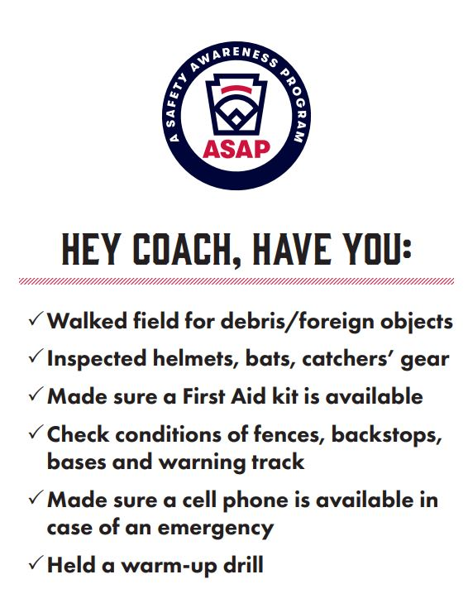

ASAP Requirement 8 – Completed Facility Survey
CRNHBB completes an annual Facility Survey in the Little League Data Center. Facility Survey information will be used by CRNHBB to plan for future improvements at the complex as well as to address any concerns that were identified as part of this survey process.
Grounds & Buildings
- NHT Rec Complex is part of the Parks and Recreational Department of Northampton Township. As such CRNHBB has a permit agreement with the township to operate the league’s activities at this complex during the season. In general, and due to this engagement, there are upkeep and maintenance responsibilities performed by the township (ex: grass cutting) and other responsibilities performed by CRNHBB (trash clean up following events; bathroom sanitation throughout the season, etc.) With that in mind, CRNHBB will work with the Township to ensure a safe environment for all participants.
- Grass must be kept trimmed for games and practices.
- Pitcher’s mound(s) and areas near home plate(s) and base paths must be kept free of holes or other dangerous conditions.
- Inspection of fields by both the home and away Managers and the umpires prior to the commencement of any games. Coaches/managers and umpires should report any unsafe condition to the field/equipment director and the safety director.
- First, Second and Third bases will be marked by white canvas or rubber covered and securely attached to the ground; however, they must be able to disengage from their anchor point to prevent injury. The use of a double first base is permissible at all levels of play.
- Maintain an adequate supply of tools and equipment to keep the field and snack stand areas in proper repair and in a clean, sanitary, and safe condition.
- Keep fields and surrounding areas free of garbage and debris. Teams are responsible for cleaning their respective dugout/bench area at the end of each game.
- Separate receptacles for the collection of common and recyclable trash are available near fields and the snack stand area.
- Keep fences, and their outfield covers, in good repair to prevent injuries.
- Annually perform and submit the Little League Facility Survey.

ASAP Requirement 9 – Concession Stand Safety Procedures
Volunteers maintain the Concession Stand. It is the responsibility of each coach to obtain at least one adult volunteer from their team to help work the Concession Stand during a particular scheduled game at NHT Rec Complex. The Volunteer Coordinator and Snack Stand Director will develop a schedule for all listed snack stand volunteers to be communicated at the beginning of each season. The Concession Stand Safety Procedures should be reviewed with each volunteer prior to their first shift. A copy of this ASAP will be maintained in the Main Shack for reference.

The person in charge of the overall responsibilities for the day-to-day operation of the Concession Stand will be properly educated and familiar with safe food handling and preparation procedure(s), as required by the Board of Health and any other Federal, State and/or Local regulatory agency or department, which includes the safe use, care and inspection of any equipment. He/she will train and assist other volunteers on proper food handling techniques/procedures and other guidelines. All volunteers in the concession stand must wash their hands prior to the start of their shift and before handling any food item.

12 Steps to Safe and Sanitary Food Service Events
The following information is intended to help you run a healthy concession stand. Following these simple guidelines will help minimize the risk of food borne illness.

- Menu: Keep your menu simple, and keep potentially hazardous foods (meats, eggs, dairy products, protein salads, cut fruits and vegetables, etc.) to a minimum. Avoid using precooked foods or leftovers. Use only foods from approved sources, avoiding foods that have been prepared at home. Complete control over your food, from source to service, is the key to safe, sanitary food service.
- Cooking: Use a food thermometer to check on cooking and holding temperatures of potentially hazardous foods. All potentially hazardous foods should be kept at 41oF or below (if cold) or 140oF, poultry parts should be cooked to 165oF. Most food borne illnesses from temporary events can be traced back to lapses in temperature control.
- Reheating: Rapidly reheat potentially hazardous foods to 165oF. Do not attempt to heat foods in crock pots, steam tables, over Sterno units or other holding devices. Slow-cooking mechanisms may activate bacteria and never reach killing temperatures.
- Cooling and Cold Storage: Foods that require refrigeration must be cooled to 41oF as quickly as possible and held at that temperature until ready to serve. To cool foods down quickly, use an ice water bath (60% ice to 40% water), stirring the product frequently, or place the food in shallow pans no more than 4 inches in depth and refrigerate. Pans should not be stored one atop the other and lids should be off or ajar until the food is completely cooled. Check the temperature periodically to see if the food is cooling properly. Allowing hazardous foods to remain at room temperature for too long has been the number ONE cause of food borne illness.
- Hand Washing: Frequent and thorough hand washing remains the first line of defense in preventing food borne disease. Please Lather your hands for 20 seconds per the CDC recommendation. The use of disposable gloves can provide an additional barrier to contamination, but they are no substitute for hand washing!
- Health and Hygiene: Only healthy workers should prepare and serve food. Anyone who shows symptoms of disease (cramps, nausea, fever, vomiting, diarrhea, jaundice, etc.) or who has open sores or infected cuts on the hands should not be allowed in the food concession area. Workers should wear clean outer garments and should not smoke in the concession area. The use of hair restraints is recommended to prevent hair ending up in food products.
- Food Handling: Avoid hand contact with raw, ready-to-eat foods and food contact surfaces. Use an acceptable dispensing utensil to serve food. Touching food with bare hands can transfer germs to food.
- Dishwashing: Use disposable utensils for food service. Keep your hands away from food contact surfaces and never reuse disposable dishware. Ideally, dishes and utensils should be washed in a four- step process:
  - Washing in hot soapy water.
  - Rinse in clean water.
  - Chemical or heat sanitizing; and
  - Air drying.
- Ice: Ice used to cool cans/bottles should not be used in cup beverages and should be stored separately. Use a scoop to dispense ice; never use your hands. Ice can become contaminated with bacteria and viruses and cause food borne illness.
- Wiping Cloths: Rinse and store your wiping cloths in a bucket of sanitize (example: 1 gallon of water and ½ teaspoon of chlorine bleach). Change the solution every two hours. Well sanitized work surfaces prevent cross-contamination and discourage flies.
- Insect Control and Waste: Keep food covered to protect them from insects. Store pesticides away from foods. Place garbage and paper waste in a refuse container with a tight-fitting lid. Dispose of wastewater in an approved method (do not dump it outside). All water used should be potable water from an approved source.
- Food Storage and Cleanliness: Keep food stored off the floor at least six inches. After your event is finished, clean the concession area and discard unusable food.

Clean Hands for Clean Foods
Since the staff at concession stands may not be professional food workers, it is important that they be thoroughly instructed in the proper method of washing their hands. The following may serve as a guide:
- Use soap and warm water.
- Rub your hands vigorously for at least 20 seconds as you wash them.
- Wash all surfaces including the backs of hands, wrists, between fingers and under fingernails.
- Rinse your hands well.
- Dry hands with a paper towel.
- Turn off the water using a paper towel, instead of your bare hands.
- Wash your hands in this fashion before you begin work and frequently during the day, especially after performing any of these activities.
- After touching bare human body parts other than clean hands and clean, exposed portions of arms.
- After using the restroom.
- After caring for or handling animals.
- After coughing, sneezing, using a handkerchief or disposable tissue.
- After handling soiled surfaces, equipment, or utensils.
- After drinking, using tobacco, or eating.
- During food preparation, as often as necessary to remove soil and contamination and prevent cross-contamination when changing tasks.
- When switching between working with raw food and working with ready-to-eat food.
- Directly before touching ready-to-eat food or food-contact surfaces.
- After engaging in activities that contaminate hands.

Top Six Causes of Food Transmitted Illness
From past experience, the US Centers for Disease Control and Prevention (CDC) list these circumstances as the most likely to lead to illness. Check this list to make sure your concession stand has covered these common causes of food borne illness.
- Inadequate cooling and cold holding.
- Preparing food too far in advance for service.
- Poor personal hygiene and infected personnel.
- Inadequate reheating.
- Inadequate hot holding.
- Contaminated raw foods and ingredients.

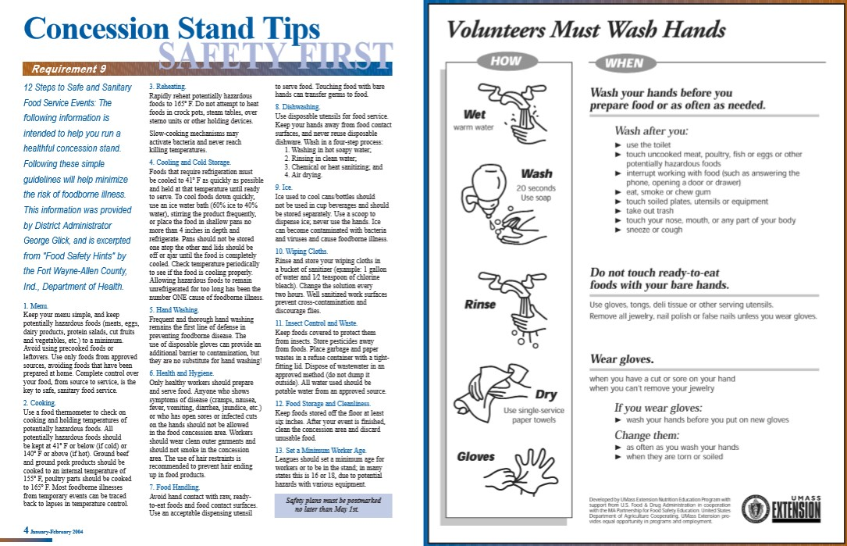

ASAP Requirement 10 – Pre-Use Equipment Check
- The Equipment Director will inspect all equipment collected at the conclusion of the previous baseball season before it is distributed to any of the team coaches at the start of the current season.
- The Equipment Director will determine whether any equipment needs to be removed and/or replaced, as well as what equipment needs to be ordered before the start of the particular season. The organization will determine if any equipment that needs to be replaced can be donated to an appropriate charity or similar organization/entity.
- All baseball bats to be used in the Majors Division and below, must be affixed with the USABat Standard marking, and deemed to be in accordance with Little League Rule 1.10 as outlined in the current edition of the Little League Rules, Regulations, and Policies. In each instance, all bats that may be used in the ensuing game must be void of any physical damage, or an altered state, which would prevent the bat from complying with the USABat Standard.
- The batting helmets must be affixed with the NOCSAE symbol, be free of cracks or other visible damage, and all of the internal padding must not be missing, tattered, torn, or frayed. No stickers are permitted on helmets, unless there is a letter of certification from the helmet manufacturer affirming the stickers are permitted to be affixed to the helmet.
- CRNHBB will ensure that equipment is inspected regularly so that defective, damaged, or worn equipment can be removed and replaced promptly. Any defective equipment noticed after distribution to teams should be identified during the pre-use inspection conducted by the coach/umpire. If a piece of equipment is rendered unusable or unsafe, the equipment should be removed from the game/practice and returned to the snack stand or the player’s personal belongings, but may not, under any circumstance, return to the field of play. Additionally, the Equipment Director and Safety Director should be notified of any league-provided equipment that has been rendered unusable or unsafe so that replacement can be provided.
- During a game/practice, all equipment should be safely stored within the team dugout or behind screens, and not within the area defined by the umpires as “in play.”
- CRNHBB will ensure that all teams have been provided with proper safety equipment for their team, including a properly stocked first aid kit.
- Protective/padded fence tops have been added to protect outfielders and other participants. Fences and any fence top should be inspected prior to starting the season and throughout to make sure they are in the proper position and not cracked or otherwise in need of repair and/or replacement.
- Fencing and backstops to protect spectators, and players/coaches who are not on the field of play are located on all fields at NHT Rec Complex. This fencing must be inspected annually and throughout the season to determine whether any repairs and/or replacements need to be performed.

ASAP Requirement 11 – Accident Reporting Procedures
- In the event of an emergency, call 911 immediately and follow the dispatcher’s instructions. Once emergency personnel arrive at the scene or the emergency has de-escalated, please file a report by following the procedures below.
- For all other accidents, please prevent the situation from worsening by responding within your training and capabilities to do so and file a report by following the procedures below.

*How to Make the Report – Incidents/Accidents can be reported by informing the CRNHBB President and/or Safety Director immediately (or within 24 hours) via online form at www.crnorthampton.com. Please try to be as specific and detailed as possible concerning any accident/incident. However, at a minimum, the following information must be provided, if possible (keep in mind that the safety and the well-being of anyone involved in an incident/accident is of paramount concern to CRNHBB, and as such, it is imperative that discretion be utilized, always, when attempting to obtain any of the below information):
- Name, address, and phone number of the individual involved.
- Date, time, and location of the incident.
- Detailed description of the incident or occurrence.
- Any witness(es) to the incident/accident.
- A description of the nature and/or extent of the injury/ies alleged to have been sustained.
- Whether first aid was rendered at the scene.
- Whether 911 was called; and
- Name and phone number of the person reporting incident.

Good Samaritan Laws
The “Good Samaritan Laws” give legal protection to people who provide emergency care to ill or injured persons. Good Samaritan laws were developed to encourage people to willingly help others in emergency situations without fear of repercussion. When citizens respond to an emergency, and act as a reasonable and prudent person under the same conditions, Good Samaritan immunity prevails. This legal immunity protects you, as a rescuer, from being sued and found financially responsible for any injury/ies a victim may sustain. For example, a reasonable and prudent person would:
  - Move the victim only if the victim’s life was endangered.
  - Ask a conscious victim for permission before giving care.
  - Check the victim for life-threatening emergencies before providing further care.
  - Summon professional help by calling 911.
  - Continue to provide care until highly trained personnel arrive.

Pennsylvania’s Good Samaritan Law can be found below:
Statutes of Pennsylvania Title 42 § 8332. Emergency response provider and bystander good Samaritan civil immunity.
(a) General rule.--Any person, including an emergency response provider, whether or not trained to practice medicine, who in good faith renders emergency care, treatment, first aid or rescue at the scene of an emergency event or crime or who moves the person receiving such care, first aid or rescue to a hospital or other place of medical care shall not be liable for any civil damages as a result of rendering such care, except in any act or omission intentionally designed to harm or any grossly negligent acts or omissions which result in harm to the person receiving emergency care or being moved to a hospital or other place of medical care.

ASAP Requirement 12 – First Aid Kits
During the season, CRNHBB will provide adequately stocked first aid kits in strategic locations throughout NHT Rec Complex. First aid kits will be located at each field in the code-secured Job Boxes. A large wall-mounted first aid kit is available at the Main Shack as well as extra supplies for restocking purposes. Additionally, first Aid kits will be provided to all coaches and are intended to be kept with the team’s equipment bag. The team dedicated kits must be returned at the end of the season for inventory and storage until the next season. The Safety Director will inspect first aid kits prior to the season and will re-order, restock or purchase new kits, as needed. If you need additional supplies for your CRNHBB provided First Aid Kit, please contact CRNHBB’s Safety Director.

CRNHBB will provide first aid kits that include a hard-shell case with supplies necessary to treat anticipated first aid-level injuries at the ball field. A general list of supplies suggested by the American Red Cross is provided below:
- A first-aid guide
- absorbent compress dressings (5 x 9 inches)
- adhesive bandages (assorted sizes)
- adhesive cloth tape (10 yards x 1 inch)
- antibiotic ointment packets
- antiseptic wipe packets
- breathing barrier (with one-way valve)
- instant cold compress
- nonlatex gloves (size: large)
- hydrocortisone ointment packets
- 3-inch gauze roll (roller) bandage
- roller bandage (4 inches wide)
- 3 x 3-inch sterile gauze pads
- sterile gauze pads (4 x 4 inches)
- Tweezers and scissors
As a reminder, medications, such as but not limited to aspirin ibuprofen or Tylenol, may only be administered to a child by their parent or guardian.

CRNHBB Automated External Defibrillator (AED) Program
As part of CRNHBB’s AED program, CRNHBB will:
- ensure that expected AED users receive training.
- maintain and test the AED according to the manufacturer's operational guidelines.
- instruct AED users to immediately contact EMS in an emergency; and
- provide EMS personnel with information as requested.

The make/model of CRNHBB’s AEDs is a ZOLL Fully Automatic AED PLUS -fully automatic defibrillator with a 2-PAK unit contains (1) adult and (1) pediatric Pak. Instructions for use, operation, care and maintenance are available in the user manual located here: AED User Manual.

During the weekly or monthly inspection process, if the unit is damaged or if the Paks have expired, the Safety Director will contact an AED vendor or AED equipment distributor for more information or to order parts/accessories. CRNHBB purchased the AED unit and uses the services of the following local vendor for the AED:

Allegiance CPR & Training

The AED will be accessible via the AED storage box located on the exterior wall of the Main Shack during all CRNHBB practices and games at NHT Rec Complex. It is advised to not store the AED over the winter (cold months) in the Snack Stand as it should be kept secured and in a dry and temperate environment to remain within operating limits of the device.

The main components of the inspection process are to ensure that the unit is operational and in good condition in the event of an emergency. An inspection of the unit should be completed prior to the start of the new season and as recommended in the maintenance procedure listed within the AED Administration Guide

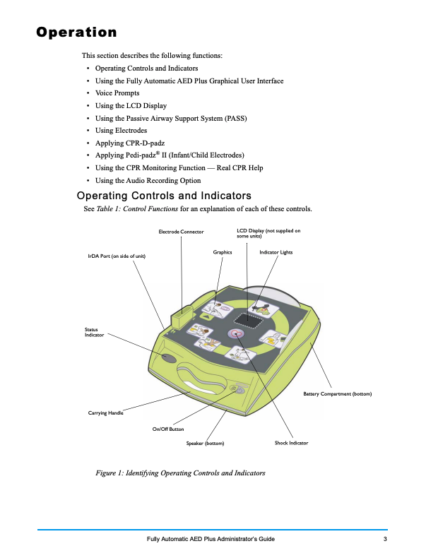
ASAP Requirement 13 – Enforce Little League Rules
Most Little League rules have a basis in safety and must be enforced at all times to maintain the safety and well-being of the CRNHBB Community. CRNHBB expects that all board members, coaches, volunteers, and parents are knowledgeable of the current season’s Little League Rule Book and will abide by the contents within. There are various rules regarding player safety such as use of the appropriate equipment, pitch count limits and player positions, and field maintenance and groundskeeping procedures. Additionally, CRNHBB values the emotional, psychological, and mental well-being of all players and participants, and as such will follow all Little League rules set forth in an effort to protect our community children from any form of neglect or abuse. Safety-related rules and expectations have been communicated within sections of this safety manual and are expected to be followed and enforced. If there are any safety-related concerns regarding these Little League rules, please contact the CRNHBB Safety Director. If there are other concerns regarding Little League rules, please contact the CRNHBB President.

ASAP Requirement 14 – Submit Player/Coach Data
On an annual basis, CRNHBB will submit all player, coach, and volunteer data via the Little League Data Center within 2 weeks following the formation of league teams via player draft.

ASAP Requirement 15 – Complete Annual Little League Survey
CRNHBB will complete the annual season survey upon notice or determination that the current season’s questionnaire is available in the Little League Data Center.

Section IX: Supplemental Safety Information

- Pediatric Sudden Cardiac Arrest
- First Aid Scenarios & Response
- Weather Guidelines (Inclement Weather and Lightning)
- Pitching Safety (Pitching Limits)
- Pre-Game Field Inspection Form

1) PEDIATRIC SUDDEN CARDIAC ARREST (SCA)
Around the country kids going into cardiac arrest are increasing at a concerning level. While we cannot prevent this from happening, we can be prepared. Please take time to read this article from the Children’s Hospital of Philadelphia.

What is sudden cardiac arrest?
Sudden cardiac arrest (SCA) occurs when the heart suddenly and unexpectedly stops beating. It is caused by the immediate loss of electrical heart function, usually from an irregular and rapid quivering of the ventricles (called ventricular fibrillation).
Rarely, the abnormal rhythms can resolve on their own. Usually, though, these rhythms degenerate to ventricular fibrillation (cardiac arrest in which the heart is quivering) or asystole (cardiac arrest in which the heart stops beating). Early emergency treatment with cardiopulmonary resuscitation (CPR) or an automated external defibrillator (AED) can help restart a stopped heart and allow return of a normal heartbeat to help prevent sudden cardiac death (SCD).
Although SCA is rare in children, it can affect anyone, even those who are physically fit. Each year, SCA claims the lives of over 2,000 children and adolescents in the U.S. and accounts for 3-5 percent of all deaths in children aged 5-19 years. It is also responsible for 10-15 percent of sudden unexpected infant deaths.

SCA Risk factors
Sudden cardiac arrest occurs more frequently in males than females, and, in children, most commonly occurs between 10-19 years of age. Still, it is important to note that SCA may occur in children of all ages, even infants.
Some other risk factors include:
- Athletic activity: Two-thirds of the deaths caused by SCA in children occur during exercise or activity. SCA is the leading cause of death in young athletes, accounting for 75 percent of all athlete-related deaths.
- Known congenital heart disease or structural heart abnormalities.
- Known abnormal heart rhythms associated with congenital heart disease. Most commonly, these include ventricular arrhythmias or atrial arrhythmias, especially the post-operative state or in the presence of a weakened heart.
- Known abnormal heart rhythms that are very rapid, even with a normal heart. For example, rapid ventricular tachycardia or atrial fibrillation with a rapid ventricular response.
- Undiagnosed cardiac conditions, especially those known to be associated with sudden cardiac arrest.
- Obesity and hypertension.
- Exposure to drugs, medications, toxins, and infectious agents, including cocaine, inhalants, recreational or club drugs, and some prescription medications.
- Sudden blow to the chest directly over the heart (commotio cordis).
- Family history of:
- Known heart abnormalities.
- Sudden death before 50 years of age
- Conditions known to cause SCA, such as long QT syndrome, Brugada syndrome, catecholaminergic polymorphic ventricular tachycardia (CPVT), hypertrophic cardiomyopathy (HCM), arrhythmogenic right ventricular cardiomyopathy (ARVC) or other familial cardiomyopathies
- Unexplained fainting or seizures
If you have a family history of any of these conditions, immediate family members should be checked out for those conditions known to be inherited or caused by a genetic mutation. This can help you identify a condition early and possibly prevent SCA or SCD.

SCA Causes
Sudden cardiac arrest is usually caused by ventricular fibrillation (VF), an abnormality in the heart's electrical system. VF causes the heart to quiver and blood flow to the body and brain to stop. VF is not the same thing as a heart attack. A heart attack results from a blockage in a coronary artery and subsequent damage to the heart muscle. A heart attack can lead to SCA.
SCA may also be associated with a sudden stop of all electrical activity in the heart (also called asystole). It can also be associated with pulseless electrical activity (PEA), a disorganized electrical activity that does not cause the heart to contract and pump blood.
Sudden cardiac death in childhood is typically caused by different heart conditions than those causing the majority of SCD in adults.
The most common causes of SCA in children are:
- Structural cardiac abnormalities (congenital heart diseases and postoperative repairs, coronary artery anomalies, or Marfan syndrome)
- Abnormalities of the electrical system of the heart (also known as primary electrical diseases), such as long QT syndrome and Wolff-Parkinson-White syndrome
- Abnormalities of the heart muscle structure or function, such as hypertrophic cardiomyopathy (HCM), arrhythmogenic right ventricular cardiomyopathy (ARVC), or dilated cardiomyopathies
- Acquired heart disease (inflammation or infection in the heart/myocarditis)
- Arrhythmias, including atrial flutter/atrial fibrillation, ventricular tachycardia (VT), ventricular fibrillation (VF), sinus node dysfunction, and complete heart block.
- Atherosclerotic coronary disease
- Commotio cordis (caused by a blow to the chest)
- Drug-induced SCA
Conditions causing SCD are typically not diagnosed prior to the arrest. In many cases, these conditions are inherited, but family members are unaware of their family history.

Symptoms of Sudden Cardiac Arrest
Warning signs and symptoms do exist in 30-50 percent of cases of SCA/SCD but are often ignored or misunderstood.
If your child has any of the warning signs or symptoms of SCA, make an immediate appointment with your pediatrician or take your child to the ER if they appear distressed in any way.
Warning signs and symptoms may include:
- Exercise related to chest pain or discomfort.
- Unexplained fainting (syncope) or near fainting, especially with or just after activity
- Repeated episodes of unexplained fainting (syncope)
- History of recurrent fainting or unusual seizures/seizure-like activity, especially with or just after activity
- Dizziness or lightheadedness
- Racing heart rate, palpitations
- Excessive fatigue or unexplained shortness of breath with exercise
- Recent viral infection with chest pain or change in exercise tolerance.
- History of a heart murmur whose cause has not been determined with certainty.
- History of high blood pressure
- Prior evaluation or treatment for a cardiac condition
- Restriction from activity because of a cardiac issue
In more than half of the cases of SCA in children, death was completely unexpected. Young people are often unaware of the risk factors and do not tell adults when they experience the symptoms. They may be frightened, embarrassed or simply unaware that what they are feeling indicates a potentially fatal problem. Educating parents, children and teenagers about the symptoms and risk factors of SCA is one way to help prevent it.

Diagnosis
If your general pediatrician suspects your child is at risk for SCA, she might refer you to a pediatric cardiologist, a doctor who specializes in heart problems in children. A pediatric cardiologist will listen to your child’s heart and ask questions about the circumstances that led to the symptoms, your child’s medical history and the family medical history. The cardiologist will read an electrocardiogram (ECG or EKG), a record of the electrical activity of your child’s heart, to determine whether a heart problem may be causing your child's symptoms. Your child’s cardiologist might order other tests, such as an exercise stress test, echocardiogram, or chest X-ray. You might be sent home with an ambulatory cardiac event monitor or a Holter monitor to continuously record your child's heart rhythm for a specific length of time as she goes about her normal activities. If your child has experienced one of the warning signs or symptoms of sudden cardiac arrest, their pediatric cardiology evaluation may indicate a normal heart needing no further testing. It could also result in further testing or follow-up evaluations, if needed.

Treatment for sudden cardiac arrest
SCA requires immediate attention. If your child collapses and does not immediately awaken, call 911 and start CPR. If an AED is available, it should be applied. The best chance of SCA survival is prompt recognition, and a planned emergency response with CPR and AED use. If sudden cardiac arrest is not treated within minutes to establish a normal heart rhythm, a person will die. The heart is either quivering or has stopped completely and cannot pump blood effectively. Blood flow to the brain and body stops and death results if life-sustaining care is not provided.

- Chain of survival
The chain of survival concept represents the sequence of five events that must occur quickly to optimize a person's chance of surviving a cardiac arrest. The five links of the chain:
- Immediate recognition of cardiac arrest and activation of the emergency response system.
- Early cardiopulmonary resuscitation (CPR) with emphasis on chest compressions.
- Rapid defibrillation using an AED can establish a normal heart rhythm in a person suffering from cardiac arrest. It is most effective when it is performed in the first few minutes of a cardiac arrest.
- Effective advanced life support.
- Integrated post-cardiac arrest care.

How CPR works
CPR manually pumps blood around the body and maintains circulation, allowing blood with oxygen to reach the body organs and brain, until a normal heartbeat can be restored. Hands-only CPR is most effective when performed right after the collapse and when an AED is also applied quickly.
CPR should continue until emergency medical services (EMS) arrive and take over, unless the affected person has a return of normal circulation (either spontaneously or after AED shock) and is awake (moving and breathing), and alert and talking. Rescue breathing as part of CPR is recommended to be used by trained health professionals.
- How AEDs work
The heart must be “defibrillated” quickly because a person’s chance of surviving drops by 10 percent for each minute a normal heartbeat is not restored.
When the heart is in sudden cardiac arrest, an AED can deliver an electrical shock through the chest (which travels to the heart) to halt the abnormal, ineffective rhythm. This enables a normal heart rhythm to resume.
AEDs are safe for use by anyone who has been trained to use them, as well as bystanders who follow instructions given by the devices. Studies have shown that sixth graders briefly trained in AED use are able to correctly operate the device as quickly as emergency medical personnel.
Broad deployment of AEDs and increased bystander CPR could prevent as many as 50,000 deaths each year in the United States that are caused by SCA. The current national survival from SCA is 8-10 percent. Placing AEDs in schools is a safe and effective way to increase survival rates to 64-74 percent.
2) FIRST AID SCENARIOS & RESPONSE
Cuts/Scrapes (bleeding)
Wear Nitrile gloves when attending to a bleeding player. Wash or disinfect hands prior to attending to player.
- Stop the bleeding. Minor cuts and scrapes usually stop bleeding on their own. If needed, apply gentle pressure with a clean bandage or cloth and elevate the wound until bleeding stops.
- Clean the wound. Rinse the wound with water. Keeping the wound under running tap water will reduce the risk of infection. Wash around the wound with soap. But do not get soap in the wound. And do not use hydrogen peroxide or iodine, which can be irritating. Remove any dirt or debris with tweezers cleaned with alcohol. See a doctor if you cannot remove all debris.
- Apply an antibiotic or petroleum jelly. Apply a thin layer of an antibiotic ointment or petroleum jelly to keep the surface moist and help prevent scarring. Certain ingredients in some ointments can cause a mild rash in some people. If a rash appears, stop using the ointment.
- Cover the wound. Apply a bandage, rolled gauze or gauze held in place with paper tape. Covering the wound keeps it clean. If the injury is just a minor scrape or scratch, leave it uncovered.
- Change the dressing. Do this at least once a day or whenever the bandage becomes wet or dirty.
- Get a tetanus shot. Get a tetanus shot if you have not had one in the past five years and the wound is deep or dirty.
- Watch for signs of infection.

If bleeding is heavy or wound is a deep laceration
- Cover the wound with sterile gauze.
- Apply direct pressure to the wound. If dressings become soaked with blood, apply new dressings over the old dressings, and continue to do so until medical attention can be rendered.
- Elevate the injured part above the level of the heart, if possible, if you do not suspect a fracture.
- Send immediately for medical assistance if bleeding is uncontrolled.
- While waiting for medical assistance, you may need to apply pressure at a pressure point. For wounds of the arm or hands, pressure points are located on the inside of the wrist (radial artery – where a pulse is checked) or on the inside of the upper arm (brachial artery). For wounds of the legs, the pressure point is at the crease of the groin (femoral artery). Steps 1 and 2 should be continued with the use of the pressure points.
- The final step to control bleeding is to apply a pressure bandage* over the wound.

*Note the distinction between a dressing and a bandage. A dressing may be a gauze square applied directly to a wound, while a bandage, such as rolled gauze or an ace bandage, is used to hold a dressing in place. Pressure should be used in applying the bandage. After the bandage is in place, it is important to check the pulse to make sure the circulation is not interrupted. When faced with the need to control major bleeding, it is not important that the dressings you will use are sterile. Use whatever you have at hand and work fast! A slow pulse rate, bluish fingertips or toes signal a bandage may be impeding circulation.

Shock

Definition:
- Shock is the failure of the cardiovascular system to keep adequate blood circulating to the vital organs of the body, namely the heart, lungs, and brain. It is common with many injuries regardless of their severity. The first hour after an injury is most important because it is during this period that symptoms of shock appear. If shock is not treated, it can progress to cause death.
Signs/Symptoms:
- Confused behavior.
- Very fast or very slow pulse rate.
- Very fast or very slow breathing.
- Trembling and weakness in the arms or legs.
- Cool and moist skin.
- Pale or bluish skin, lips, and fingernails.
- Enlarged pupils.
First Aid:
A good rule to follow is to anticipate that shock will follow an injury and to take measures to prevent it before it happens. If shock is observed follow these steps below:
- Putting a victim in a lying-down position improves circulation.
- If the victim is not suspected of having head or neck injuries, or leg fractures, elevate the legs.
- If you suspect head or neck injuries, keep the victim lying flat.
- If the victim vomits, turn on their side.
- If the victim is experiencing trouble breathing, place them in a semi-reclining position.
- Maintain the victim’s body temperature, but do not overheat.

Head Injuries (Concussion)

Causes:
- Direct impact or blow to the head or jaw.
Signs/Symptoms:
- Dizziness, ringing in the ears, headache, nausea, blurred vision, and slurred speech.
- Loss of balance, confusion, memory loss and disorientation.
- Pupils’ unequal in size and do not constrict when subjected to light.
Prevention:
- Wearing helmets and mouthpieces when there is a risk of trauma to the head/face. Also, please use common sense when evaluating head injuries, and do NOT allow a parent or child to influence a coach’s decision to allow a player to continue to participate in a game or practice after suffering a head injury. For more information, please refer to: HEADS UP to Youth Sports: Online Training | HEADS UP | CDC Injury Center
First Aid:
- If any of the above symptoms are present and persist, immediately call for medical assistance.
- Immediately remove the athlete from the game or practice.
- Athlete cannot return to competition until released by a physician.

Asthma

Causes:
- Allergic reaction to dust or molds.
- Exposure to cold environments.
- Adverse response to strenuous exercise.
Signs/symptoms:
- Tightness of chest.
- Inability to breathe.
- Wheezing, trouble exhaling.
Prevention:
- Be aware of athletes who may have asthma.
- Remind them, and their parents, to bring their medication.
- Give athletes with asthma frequent rests after exertion.
First Aid:
- Reassure the athlete and place them in a comfortable position.
- Ask, “Do you have any asthma medication?”
- Assist with administering medications.
- Monitor athlete for improvement.
- Send emergency medical assistance if the athlete does not improve.
- Begin CPR if necessary.

Eye Injuries

First Aid:
- Floating objects in the eye (example: dust, dirt, debris, insects, eye lash etc.) which can be visually identified as “not embedded” in the eye, can be flushed from the eye with water or first aid solution (eye wash bottles). If the object cannot be removed in this manner, the victim should immediately seek medical attention.
- Never attempt to remove objects embedded in the eye! First Aid care for these injuries consists of bandaging BOTH eyes and seeking professional care promptly! An inverted paper cup covered with a bandage is appropriate for serious eye injuries while the victim is transported to the hospital. Eye patches or large bandages/gauze pads used to cover the eye until the injured person can seek medical attention.

Heat Emergencies
There are three types of heat emergencies you may be required to treat.
- Heat Stroke
Definition:
- This is the most serious type of heat emergency. It is life threatening and requires immediate and aggressive treatment! Heat stroke occurs when the body’s heat regulating mechanism fails. The body temperature rises so high that brain damage and death may result unless the body is cooled quickly.
Signs/symptoms:
- The victim’s skin is hot, red, and usually dry.
- Pupils are very small.
- The body temperature is very high, sometimes as high as 105 degrees.
- Confusion.
- Difficulty walking or talking.
First Aid:
- Summon professional help immediately.
- Get the victim into a cool place.
- Cool the victim as quickly as possible in any manner possible. Place the victim into a bathtub of cool water, wrap in wet sheets or towels, and place in an air-conditioned room.
- Do not give the victim anything by mouth.

- Heat Exhaustion
Definition:
- Heat exhaustion is less dangerous than heat stroke. It is caused by fluid loss, which in turn causes blood flow to decrease in vital organs, resulting in a form of shock.
Signs/symptoms:
- Cool, pale, moist skin.
- Heavy sweating.
- Dilated pupils (wide).
- Headache.
- Nausea and/or vomiting.
- Dizziness.
- My body temperature will be near normal.
- Increase pulse.
- Cramps in the abdomen or limbs.
First Aid:
- Get the victim out of the heat and into a cool place.
- Place in the shock position, lying on the back with feet raised.
- Remove or loosen clothing.
- Cool by fanning or applying cold packs or wet towels or sheets.
- If conscious, give water to drink every 15 minutes.
- Note: Heat Exhaustion can progress to heat stroke if left untreated.
- Heat Cramps

Definition:
Heat cramps are muscular pain and spasms due to heavy exertion. They usually involve the abdominal muscles or legs. It is thought this condition is caused by loss of water and salt through sweating.
Signs/symptoms:
- Muscle cramps
- Lightheadedness
- Weakness
- Nausea and vomiting
- Headache
First Aid:
- Get victim to cool place.
- If they can tolerate it, give one-half glass of cool water every 15 minutes.

Note: Heat cramps can usually be avoided by increasing fluid intake prior to and during activity in hot weather. Drinking fluids (water and electrolytic liquids) prior to playing outside in hot weather and throughout the game/practice is recommended.

Insect Bites

Definition:
- Insect bites and stings can be life threatening to people with severe allergies to the insect’s venom.
Signs/symptoms of allergic reaction:
- Pain.
- Swelling of the throat.
- Redness or discoloration at the site of the bite.
- Itching.
- Hives.
- Decreased consciousness.
- Difficulty or noisy breathing. **Be aware of which children on your team are reported to have bee sting allergies, and if they require an Epi-pen should they be stung. Reminder that players with Epi-Pens must have a parent/guardian present at all times, as only they can administer medication.
First Aid:
- Be alert for signs of allergic reaction or shock and seek medical attention as quickly as possible for these victims! **If the victim has an epi-pen have parent or his/her responsible adult/guardian administer the epi-pen. If conscious, the athlete can administer it himself.
- If a stinger remains in the victim, you may try to remove it carefully with tweezers or by scrapping it with the edge of a credit card. Be careful not to squeeze the stinger, as this will inject more venom.
- Once a stinger has been removed, the wound should be washed well with soap and water. Cold compresses will help relieve pain and swelling.
- Keep the stung area lower than the heart to slow circulation of the venom.
Unconscious Person
First Aid:
- Send immediate emergency medical assistance.
- Do not move unless absolutely necessary. Assume head or neck injured until ruled out.
- Stabilize the athlete’s head and neck.
- Monitor airway, breathing, circulation and provide CPR if necessary.

Diabetes (Insulin Shock)

History:
- Know which of your athletes are diabetic and monitor for hypoglycemia (low blood sugar). This information should be disclosed on player medical data forms and kept on file.
Signs/symptoms:
- Dizziness, headache, hunger, weakness.
- Perspiration, pale cold skin, rapid pulse, confusion, disorientation which may progress to unconsciousness.
First Aid:
- Give complex carbohydrates such as crackers, fruit, sugar, candy, soda, or fruit juice.
- Send emergency medical personnel if the athlete does not recover within minutes.

Fractures, Sprains, Strains & Dislocations
Fractures, sprains, strains, and dislocations may be hard for the lay person to tell apart. For this reason, first aid treatment of any of these conditions is handled as though the injury was a fracture.

Signs/symptoms
- “grating” sensation of bones rubbing together.
- Pain and tenderness.
- Swelling.
- Bruising.
- Inability to move the injured part.
First Aid: “R.I.C.E.”
- Rest: Reduce or stop using the injured area for 48 hours.
- Ice: Apply a cold pack, ice bag or a plastic bag filled with crushed ice on the injured area for 20 minutes at a time.
- Compression: Compression of an injured ankle, knee or wrist may help reduce swelling. Use elastic wraps, special boots, air casts or splints. Have athlete ask his or her doctor which is best.
- Elevation: Keep the injured area elevated above the level of the heart.
- Immobilize the effected body part.

Note: Severe injuries such as obvious fractures and dislocated joints, or if there is prolonged swelling and/or prolonged severe pain, require professional medical care.

Knocked out permanent tooth/teeth.

First Aid:
- Rule out head injury or concussion.
- If concussion present, treat concussion first.
- Place wet gauze over the tooth socket and have the athlete bite down and put pressure on the area to control bleeding.
- Find tooth and place tooth in the best possible transport medium available and immediately see a dentist without delay. Preferably within 30 minutes to have the best chance for success.
- Handle the tooth by the crown portion of the tooth only. Do not touch or handle the root. Do not place your tooth in gauze, tissue or tap water for transport to dentist.
- The best transport medium in order of preference is:
- Cold whole milk.
- Saline Solution.
- Saliva of victim or another adult.
Prevention:
- Athletic face/mouth protective devices (face masks worn for catchers); face cages on batting helmets; and custom-fit mouth guard worn during athletic participation. Coaching on collision avoidance – appropriate baserunning and sliding – calling for the ball/communication. Avoid drills or games that put players in danger of running into each other or other fixed objects.

3) WEATHER GUIDELINES AT THE BALLFIELD
“If you can hear it, clear it. If you can see it, flee it.”
CRNHBB will keep an airhorn in the Main Shack that will be sounded in the event of severe weather emergencies that require the clearance of all fields. If you hear an airhorn (single blast) – SEEK SHELTER IMMEDIATELY and AWAIT FURTHER INSTRUCTION (from coach or game/league official) on whether games/practices are able to resume.

Note: The airhorn is NOT a toy and false alarms (pushing the trigger without the need to evacuate the fields) must not happen. Only an adult volunteer may sound the air horn in the event of an emergency. Please read all air horn instructions before use and never sound near or around one’s ear).

Lightning Safety
Not wanting to appear “overly cautious” many people wait far too long before reacting to a storm threat. The safety recommendations outlined here are based on lightning research and lessons learned from the unfortunate experiences of thousands of lightning strike victims.

Most experts recommend that outdoor athletic events should be postponed when the thunderstorm approaches from a distance of six miles. We are not meteorologists or weather experts, so the best way to gauge the distance of a thunderstorm is to measure the elapsed time from the flash to bang. A count of five seconds equals one mile, so a count of thirty seconds equals a distance of six miles. If you count less than 30 seconds between a flash and a bang, the storm is “close enough” to be a threat. In most cases if you hear thunder or see a flash of lightning, you should make your way to a safe haven and await further instruction. Since all fields may or may not face an incoming storm – if you hear the airhorn blast, that means GET OFF THE FIELD IMMEDIATELY, SEEK SHELTER and AWAIT FURTHER INSTRUCTIONS

If the snack stand is not open (possible during practice only nights or “light” game nights/days), or you see or hear thunder/lightning at or near the field - Coaches/Umpires and League officials should determine when a game/practice scrimmage or other outdoor activity needs to be postponed due to weather safety concerns. The following weather conditions warrant a stoppage of play and movement to a safe location:
- If lightning is observed.
- If thunder is heard.
- If the time between lightning and corresponding thunder is 30 seconds or less.
- If the skies look threatening and the weather forecast predicts that a storm will occur in the area.
- If there are any types of weather-watches in the area

If you are caught outside in the storm and cannot get to a haven such as building structure or vehicle…
- Go to a low-lying, open place away from trees, poles, or metal objects. DO NOT hide under bleachers.
- Be a very small target. Squat low to the ground. Place your hands on your knees with your head between them. Make yourself the smallest target possible.
- DO NOT lie flat on the ground. This will make you a larger target!
- If you feel your hair stand on end in a storm, drop into the tuck position immediately. This sensation means electric charges are already rushing up your body from the ground toward an electrically charged cloud.

If someone is struck by lightning…
- People struck by lightning carry no electrical charge and can be handled safely.
- Immediately call for help…9-1-1.
- The injured person has received an electrical shock and may be burned, both where they were struck and where the electricity left their body. Check for burns in both places. Being struck by lightning can also cause nervous system damage, broken bones and loss of hearing or eyesight.
- Give first aid. If breathing has stopped begin rescue breathing. If the heart has stopped beating, begin CPR and find a CRNHBB volunteer that is trained to utilize the AED devices, if necessary.

When can activities be resumed?
Because electrical charges can linger in clouds after a thunderstorm has passed, experts agree that people should wait at least 30 minutes after the storm (after audible thunder or visible lightning) before resuming activities. Additionally, the field of play must be re-evaluated if weather such as heavy rains or high winds caused any damage or unplayable field conditions during the storm.

League Wide Alerts
In the case of an unplayable field or potential threat, CRNHBB will utilize an SMS message to all Commissioners. Commissioners will then inform each coach within their division. Coaches will utilize GameChanger or other applications to quickly communicate field status to parents and players. Additionally, field status updates (open or closed) will be posted on CRNHBB’s website found here: Northampton Baseball - crnorthampton.com

4) PITCHING SAFETY (LL PITCH COUNT)
Although some view the Little League pitch count requirement to manage overusing an “ACE” on the mound, the roots of this rule are deep seeded in player safety. The eligibility of a player to pitch in a Little League baseball game is governed by a tiered pitch count that is tied to the number of pitches thrown in a game by a pitcher of a certain age division. The pitch count determines how many days of rest are required before said player may pitch again in a game. Coaches are responsible for understanding and complying with all Little League pitch count rules for their respective division of play. At no time may a pitcher throw to a new batter if his/her pitch count limits have been reached. Under no circumstances may a player pitch (3) consecutive day. Little League pitch count limits per day are listed below:

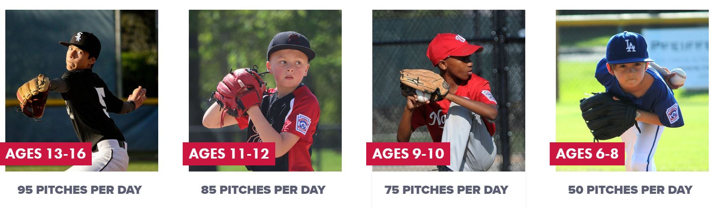
Baseball pitch count thresholds for required rest days are listed below:
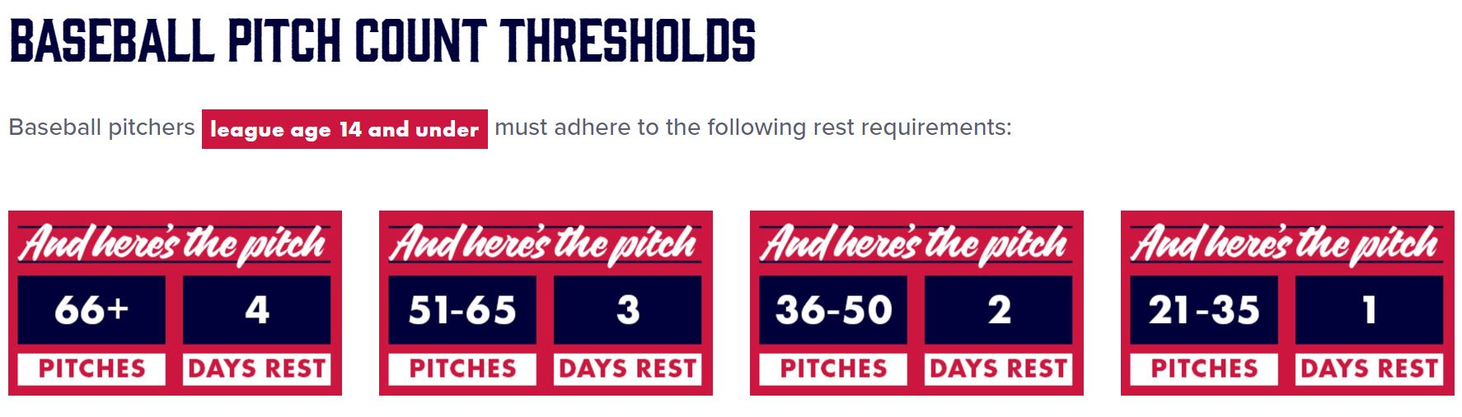

Exception: If a pitcher reaches the limit imposed in Regulation VI(c) for his/her league age while facing a batter, the pitcher may continue to pitch until any one of the following conditions occurs:

- The batter reaches base.
- The batter is put out.
- The third out was made to complete the half-inning of the game.
- The pitcher is removed from the mound prior to the batter completing his/her at bat.

NOTE: If a pitcher reaches 40 pitches while facing a batter, the pitcher may continue to pitch, and maintain their eligibility to play the position of catcher for the remainder of that day, until any one of the following conditions occurs:
- that batter reaches base.
- that batter is retired.
- the third out is made to complete the half inning or the game; or
- the pitcher is removed from the mound prior to the batter completing his/her at-bat.

The pitcher would be allowed to play the catcher position provided that pitcher is moved, removed, or the game is completed before delivering a pitch to another batter. If a player delivers 41 or more pitches, and is not covered under the threshold exception, the player may not play the position of catcher for the remainder of that day.

Additionally, Little League has a specific rule governing the pitcher/catcher position limits of a single player in a day:

“Any player who has played the position of catcher in four (4) or more innings in a game is not eligible to pitch on that calendar day.

A player who played the position of catcher for three (3) innings or less, moves to the pitcher position, and delivers 21 pitches or more in the same day, may not return to the catcher position on that calendar day.

EXCEPTION: If the pitcher reaches the 20-pitch limit while facing a batter, the pitcher may continue to pitch, and maintain their eligibility to return to the catcher position, until any one of the following conditions occur:
- that batter reaches base.
- that batter is retired.
- the third out is made to complete the half-inning or the game; or
- the pitcher is removed from the mound prior to the batter completing his/her at-bat.”

For more information about Little League Pitching Rules, please review the most current version of the Little Leagues Playing Rules or the agreed upon Addendums in partnership with other Local Leagues.

5) PRE-GAME FIELD INSPECTION CHECK LIST
MANAGERS NAME:
FIELD:
DATE: Time:
Field Condition | Good | Poor | Catchers Equipment | Good | Poor
Backstop Intact |  |  | Hockey Catchers Helmet
Home Plate Intact |  |  | Dangling Throat Guard
Bases Secure (with disengage) |  |  | Protective Cup (boys)
Pitcher’s Mound Safe |  |  | Catcher’s Mitt
Batter Box Lined/Level |  |  | Chest Protector
Infield Fence |  |  | Shin guards
Outfield Fence |  |  | Dugouts | Good | Poor
Foul Lines Marked |  |  | Fencing
Infield ground conditions |  |  | Player Bench
Outfield ground conditions |  |  | Trash Cans available
Warning Track |  |  | Clean Up Is Needed
Coaches’ boxes Lined |  |  | Dug out (walls/roof, etc.)
Free Of Foreign Objects |  |  | Spectator Area | Good | Poor
Grass Surface Even |  |  | Bleachers
 |  |  | Protective Screens
Player Equipment | Good | Poor | Concession area/benches
Batting Helmets |  |  | Parking Area Safe
Jewelry Removed |  |  | Safety Equipment | Good | Poor
Shoes/Bats Inspected |  |  | First-aid Kit Each Team
Proper Cleats/athletic shoes |  |  | Medical Release Forms
Athletic Cups (boys) |  |  | Ice Pack/Ice
Full Uniform |  |  | Safety Manual
Bats Meet Standards |  |  | Injury Report Forms
 |  |  | Drinking Water
Provide a comment for any “poor” response.

REPORT ANY PROBLEMS TO YOUR LEAGUE PRESIDENT OR SAFETY DIRECTOR
This form is intended as a “reminder.” It is not mandatory to complete prior to EVERY game, however all items on this form should be visually inspected and confirmed as available and in good condition by the coach/umpire before play is permitted on the field.

